INTRACARDIAC THROMBUS IN A WARFARIN RESISTANT PATIENT
F. Khan, B.C. Berger
Abington Jefferson Health, Abington, PA, USA

Introduction: Warfarin has been the drug of choice for prophylaxis of thromboembolic events in atrial fibrillation and post-valvular surgeries. Its resistance is not an unknown phenomenon. We report a case of increscent intracardiac thrombus in a patient with warfarin resistance leading to recurrent thromboembolic events.
Case Report: Our case is of a 75-year-old African-American female with history of paroxysmal atrial fibrillation (PAF) for which she was on warfarin. She underwent replacement of mitral valve (MV) with a bioprosthetic valve for mitral regurgitation. Given the history of PAF, left atrial appendage was over-sewn. Two- and three-months postoperatively she had two episodes of CVA, respectively despite adequate anticoagulation. Transesophageal echocardiogram (TEE) during the latter episode showed a thrombus on the MV ring (Fig. 1). Four-month post-surgery she had a new splenic infarct and warfarin was continued. She returned at six-months postoperatively with recurrent splenic infarct. TEE showed enlarged thrombus on the MV (Fig. 2). She was considered warfarin resistant. She was not a candidate for novel anticoagulation (NOAC) because of the prosthetic valve, so enoxaparin was chosen.
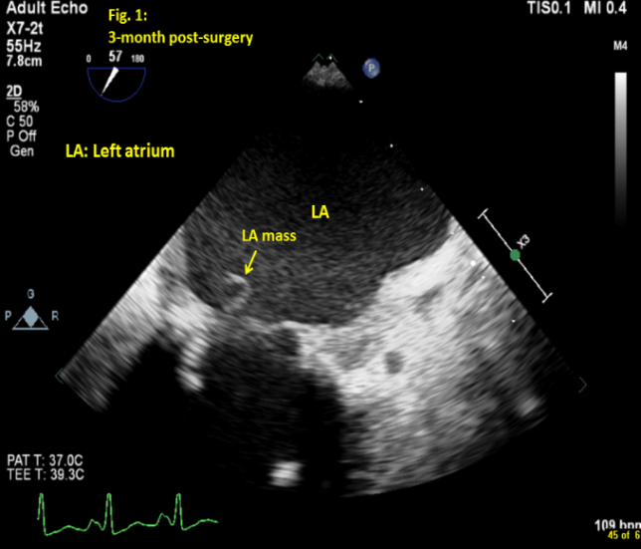
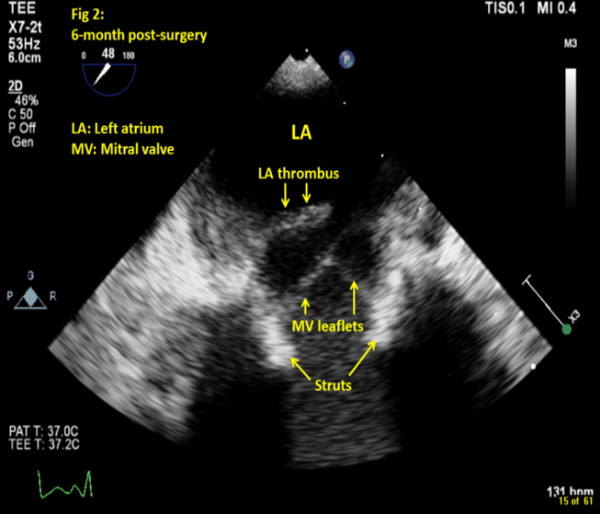
Conclusion: There is no data to support genetic testing to guide warfarin dosing in African-American patients. Alternative anticoagulation should be considered in such patients.

